**Team Id : PNT2022TMOD06442**

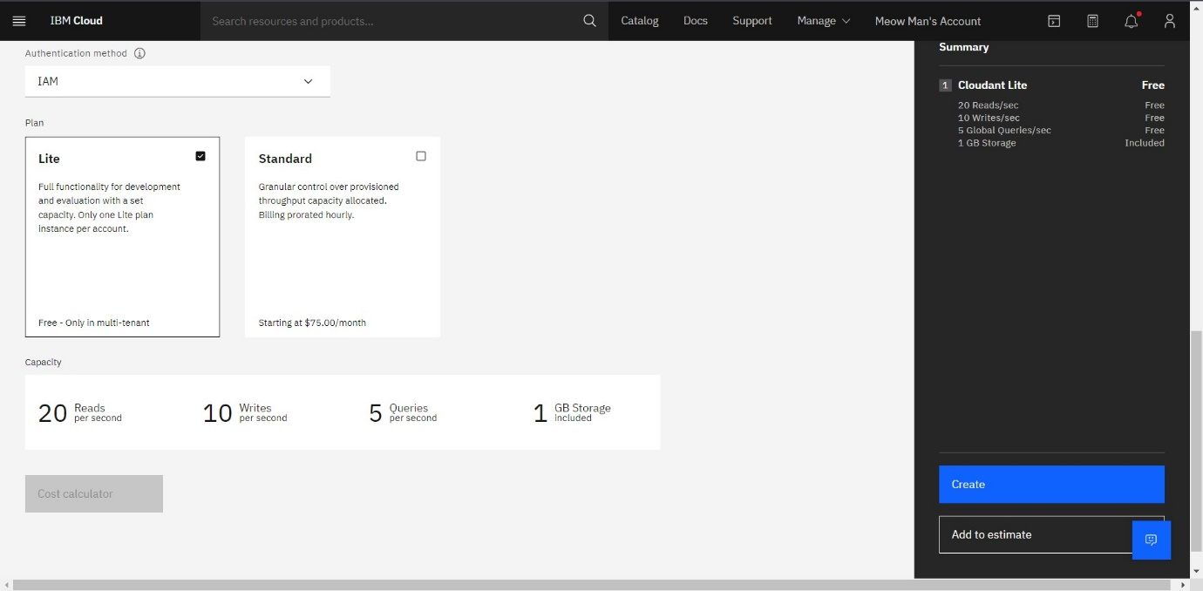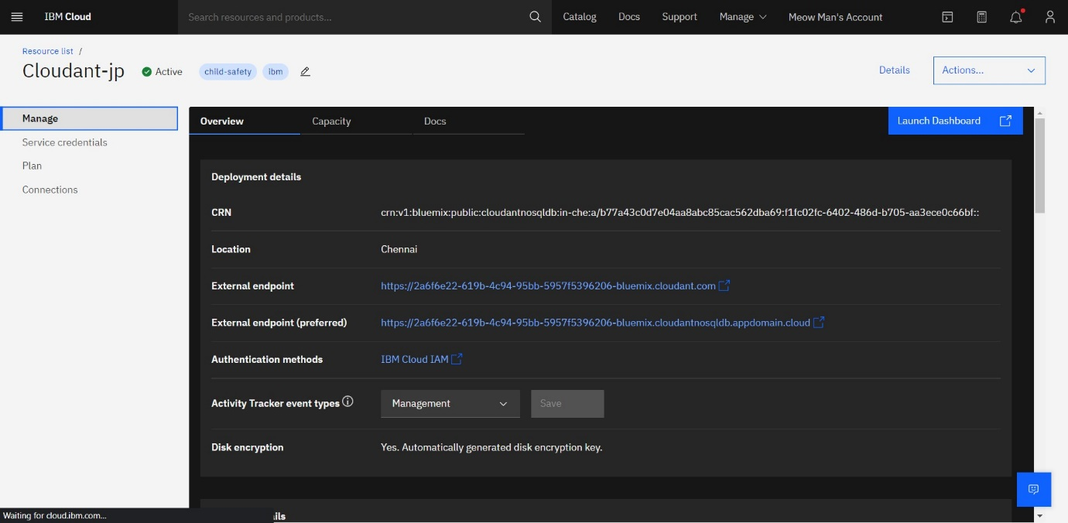

Create A Database In Cloudant DB

Aim: To create a database in Cloudant DB to store location data.

Steps followed:

* Logged in to IBM Cloud account
* Navigated to `./resources`
* Clicked on the “Create Resource +” button
* Searched for “Cloudant”
* Chose the “Lite Version” and clicked on “Create”
* The Cloudant database resource was created successfully
* Clicked on Launch Dashboard

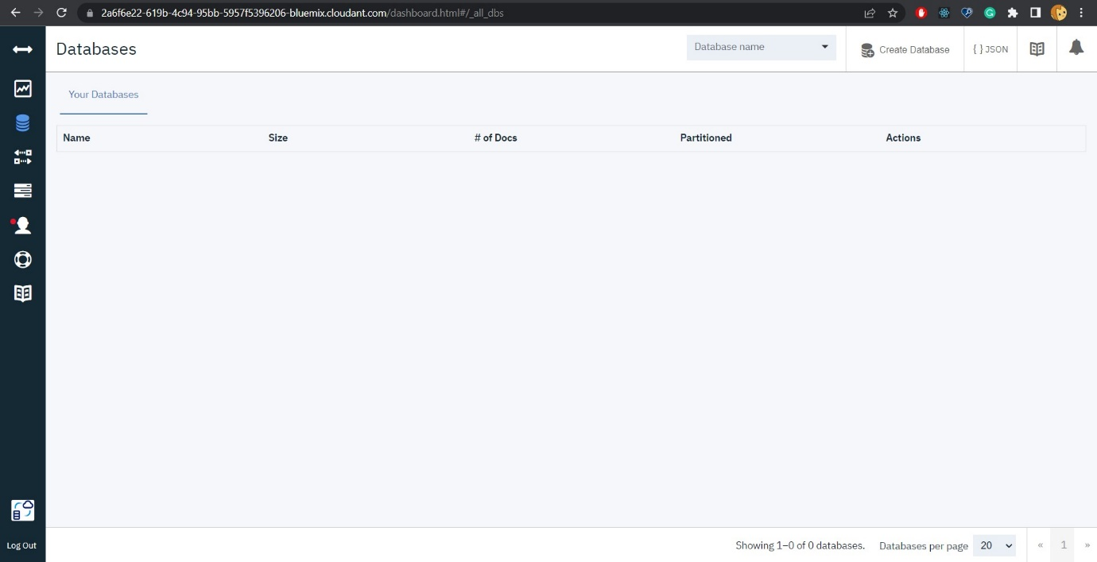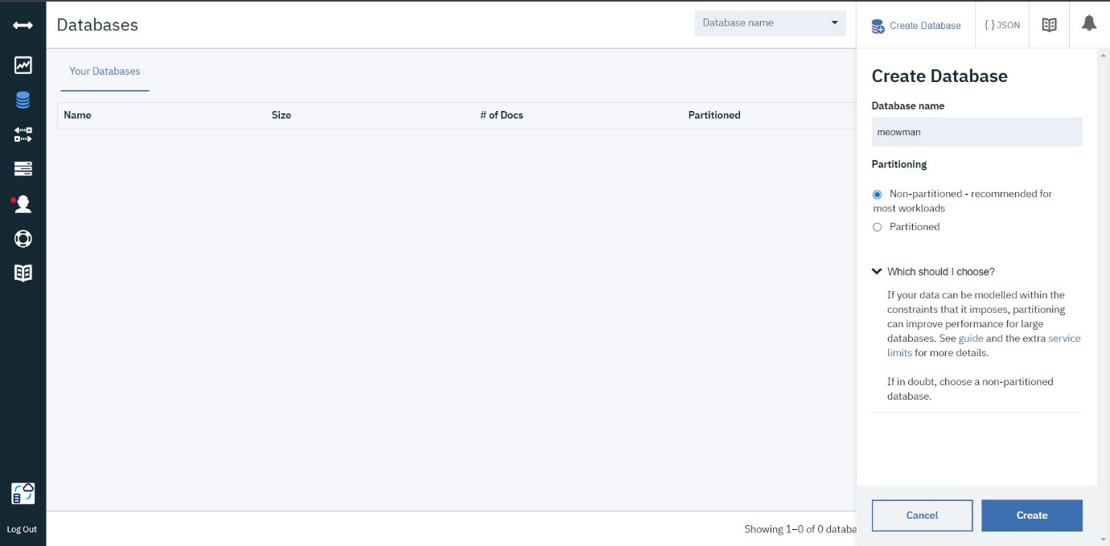

* Clicked on “Create Database”. Entered “meowman” as the database name and the “Non-partitioned” option
* The database “meowman” was created successfully

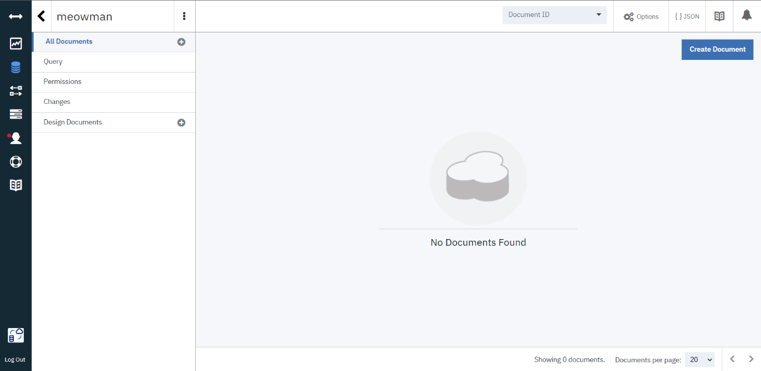

Result:

A database to store the location data was created successfully on Cloudant DB